Team 518: Movement through DEEP regolith
Joshua Baldwin¹, Enrique Chocron², Emily Dawson³, Andres Hernandez⁴, Joseph Way⁵

¹FAMU-FSU College of Engineering, Email: jpb18@fsu.edu
²FAMU-FSU College of Engineering, Email: eac17e@fsu.edu
³FAMU-FSU College of Engineering, Email: erd18b@fsu.edu
⁴FAMU-FSU College of Engineering, Email: ah18t@fsu.edu
⁵FAMU-FSU College of Engineering, Email: joseph1.way@famu.edu

Abstract
Wheeled rovers become unstable on the Moon because of the diverse terrain. The surface consists of regolith, a loose mixture of dust and gravel, that is small and sharp, which ruins equipment on the moon. The task is to see if a novel form of movement would be useful on the lunar surface. This project attaches a novel foot and ankle joint to Dr. Clark’s ET-Quad, a four-legged robot meant to travel over different surfaces. The design limits points of failure and mitigates regolith interference. The foot relieves slipping problems through extrusions on the bottom to increase grip. The traction feature has Rowed Spikes, which has a coefficient of dynamic friction of 1.11 and provides ease for manufacturing. The foot models a snowshoe by using a lattice grid to decrease pressure on the surface and reduce shifting regolith. The team performed drop tests to determine the best lattice design. During the drop test, cameras view the surface impact to analyze the change in depth and the plumes of regolith created. The lattice design with a 60% reduction per unit area has the best characteristics, including a penetration depth of 3.57 mm from experimental results. For movement, the ankle joint will attach to a leg from ET-Quad for a Boom Test. This confirms endurance and future integration with the robot. The final selected design has a lattice that causes the least regolith disturbance, which combines with traction extrusions that supply the greatest resistance to slipping, and unification with ET-Quad.

Keywords: Regolith, lattice, plumes, slip
Nomenclature
$F_{f}$ Force of Friction
$μ_{s}$ Coefficient of Static Friction
$μ_{k}$ Coefficient of Dynamic Friction
$N$ Normal Force

- INTRODUCTION
Regolith is loose, unconsolidated rock and mineral debris that blankets the surface of the Moon. Due to the lack of atmosphere, regolith is formed when meteorites impact the lunar surface, breaking down and melting the rocks into smaller shards. This leaves the debris as sharp and jagged grains of sand and dust. The dust encounters solar winds and is made from ferritic material, which causes it to become electrostatically charged. This gives the regolith very adhesive properties.
The adhesive properties cause it to stick to various materials from fabric to metal. With grain sizes small enough to fit into the cracks of fingerprints, regolith is difficult to remove. The regolith can get kicked up by astronauts and rovers, which covers exposed areas and affects equipment. Current rovers get stuck in deep regolith because their wheels have limited traction and regolith will clog certain parts. For this project, the task is to find a new method of moving through deep regolith and to find a way to limit the effect of lunar regolith on future legged lunar systems.
The goal is to design a novel form of movement that can successfully traverse the lunar surface. To achieve this, a new foot attachment was designed for ET-Quad – a quadrupedal robot created with the ability to move through different resistive media by walking, climbing, and swimming. The foot design needs to reduce regolith displacement, minimize the risk of slipping, and provide support for robots.
To accomplish this, the design needs to be lightweight, minimizing the cost of sending the robot to the moon. The design needs to limit the amount of regolith displaced, reducing the risk of regolith affecting the joints and encountering any equipment on the robot. The design must also be regolith resistant; it must be made such that regolith cannot negatively interfere with the design.

- TARGETS AND METRICS
All materials and methods that have been used in the work must be stated clearly. Subtitles should be used when necessary.
To define targets and metrics for this project, the team had to define which aspects of the project are most important to the project sponsor. Utilizing the customer’s needs, targets and metrics for Project Achilles were defined. The most important critical function for the design is to allow proper movement of a robot through regolith, while preventing regolith particles from damaging any hardware. The critical targets and metrics for the project reflect these functions.
To successfully move through regolith, each foot should be able to support the weight of ET-Quad. A metric was developed stating that each foot should withstand and support 156 N, assuming Earth conditions. This force represents twice the weight of the robot, which occurs while running. To ensure each foot can be properly integrated with ET-Quad, a size metric was created. After a discussion with Dr. Clark, it was decided that each foot should not exceed three times the size of the original rover’s feet, which is 56 x 35 x 52 mm.
Considering that taking equipment to the moon is incredibly expensive, a key goal was determined to make the design lightweight. A target was set to determine a maximum weight. A metric was created to satisfy this target where each foot would not exceed 100 g.
To successfully achieve motion for the rover, the feet should not slip or completely sink in deep regolith. A target was created that would dictate that the design with the largest coefficient of friction would be selected to minimize slip. A target to prevent sinking was created, establishing that the design with the least regolith disturbance or plume effect would be selected.

- DESIGN ATTRIBUTES
The foot design consists of a lattice to reduce the displacement of the regolith, a traction feature to prevent slippage, compliance to handle the weight of the robot, and bore holes to integrate with ET-Quad. All the attributes will be explained further in the paper. Figure 1 shows the final model after testing was conducted.

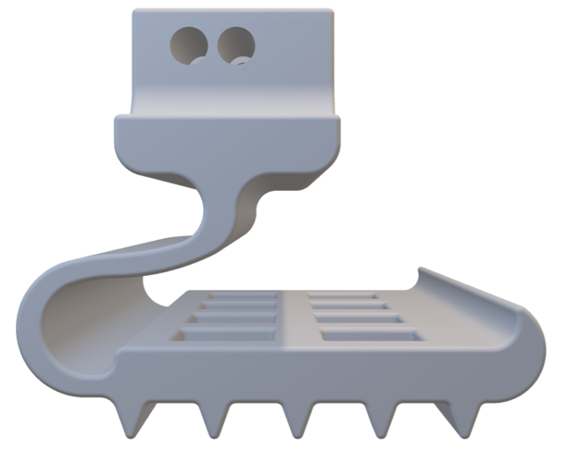
FIGURE 1: FINAL ACHILLES MODEL

- TESTING
4.1 Regolith Displacement Test Assembly
A drop test of a flat plate with different lattice designs was performed to determine which geometry would be most beneficial to Project Achilles. Area reduction per unit area consists of removing material at the center from a 25.4 mm x 25.4 mm square region. Figure 2 shows an example where 40% of the area is removed.

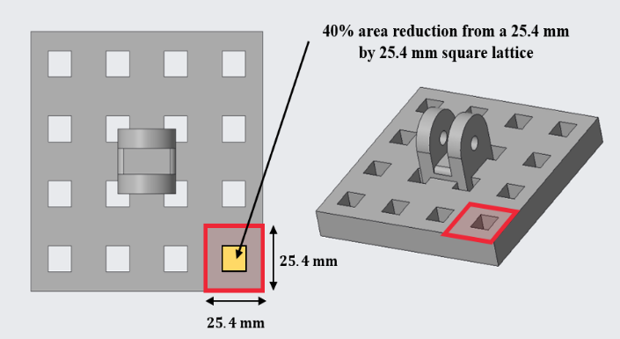
FIGURE 2: FOOT SAMPLE WITH 40% AREA REDUCTION FROM UNIT SQUARE

The experiment consisted of dropping the flat plate at a fixed height into regolith simulant and measuring two important pieces of data: the penetration depth and the regolith plume profile. During the experiment, 25%, 40%, 50%, 60%, and 75% area reduction per unit area was used to analyze the response of the penetration depth and the plume generation as a function of the material subtraction.
The Regolith Displacement Test Assembly (RDTA) was created as the test rig to provide a consistent and controlled environment for such experiments in Earth-like conditions, which was a key assumption of the project.
The test consisted of five different components. The first component is the container, a (254 x 254 x 254) mm acrylic box that stores regolith. The simulant used for the drop test was a simulant created by Team 518. RS-518 is a good approximation for regolith simulant and its composition consisted of 55% dry sand, 35% baby powder, and 10% coarse coffee grounds. A support and guide keep the dropping device which is used to attach the foot sample and allows a smooth and perpendicular motion of the parts during the experiment. A dropping device, which is a two-piece arm that has the connects to the foot sample, allows the user to add additional mass to the system to maintain a constant mass during the experiment for all the samples.

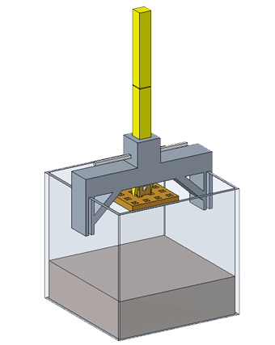
FIGURE 3: ASSEMBLED TEST RIG (RDTA)

The experimental procedure for the drop test was created to ensure consistency between trials. Since each foot sample had a different mass, the foot sample that weighed the most was used as a reference and counterweights were added to the dropping device for the foot samples that had a smaller mass. The intent was to have a similar mass of a foot sample with the dropping device to ensure the force due to gravity would be the same for every experiment. This allowed the only variable factor to be the pressure exerted at the bottom of the foot sample on the surface.
A camera with slow-motion settings was used to capture the regolith plume profile during the drop test. The camera was aligned so that it matches the front side of the regolith container. Some markers are created to make the measurement more consistent. Although it is not required, a camera or cell phone holder might provide more accurate measurements. The distance between the camera system and the regolith container is not fixed, it depends on various factors. However, the idea is that each measurement is consistent to allow better data analysis.
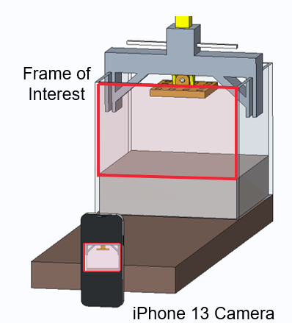
FIGURE 4: DATA AQCUISITION FOR PLUME DATA

The recording started before releasing the pin for the drop test. For better results, a dark cover underneath the test assembly to the camera system was used. Light settings in the room where the experiment is taking place would vary a lot. It is important to have good diffuse illumination, not direct. The user that removed the release pin did not have their shadow present in the video recording.
Once the video was recorded, the frame when regolith was disturbed the most was selected. This was selected by looking at the settings of the video and taking a screenshot. Although it reduces the resolution, this minimized the time during post-experimental data processing. Other alternatives would be importing the video into editing software and selecting the exact time frame for more precision.
For the penetration depth, an initial measurement was taken before performing the set of experiments. This was done to have a reference value to determine the penetration depth of each test drop. The intent was to measure the distance from the lower part of the foot at the highest elevation to the surface of the regolith simulant. One user carefully moved the dropping device with the foot attachment towards the surface, without sinking it. At the top of the guide, the reference mark was placed on one side of the dropping device. After performing drop tests, a measured value mark was placed somewhere above the reference mark. This was because the dropping device with the foot will sink into the regolith simulant, displacing material around the sample.

4.2 Traction Test
The traction test was conducted at the Regolith Simulant Fields at NASA-MSFC. Background research emphasized the need for an increased level of traction due to the high amounts of slippage that can occur on the lunar surface. The Traction Test was used to determine the static and dynamic coefficients of friction. The static coefficient of friction, $μ_{s}$, is determined by the force required to make an object start moving when it begins at rest. The dynamic coefficient of friction, $μ_{k}$, is determined by the force required to keep an object moving along the surface at a steady pace.
Five different traction designs were tested: the Claw, Spikes, Angled Cleats, Hook and Rails, and Rowed Spikes. Each design was 3D-printed with a basin on top so mass could be added to each design. Each design was placed lightly on the regolith surface with 100 g mass added in the basin, then attached a force gauge, and pulled across the regolith surface. This experiment was completed six times for each design: three times to determine $μ_{s}$ and three times to determine $μ_{k}$. Figure 5 shows the Traction Test being performed at NASA-MSFC.

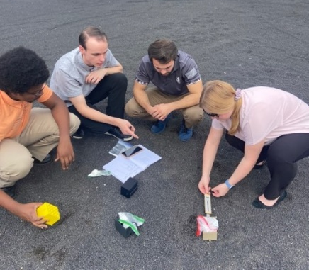
FIGURE 5: TEAM 518 CONDUCTING THE TRACTION TEST AT NASA-MSFC

4.3 Movement Test
Movement tests were conducted at the Center for Intelligent, Systems, Control, and Robotics (CISCOR) Lab at the FAMU-FSU College of Engineering. A Boom Test was used to experimentally verify the Achilles model. The apparatus consisted of a beam that was connected from a rotating motor to an individual leg mechanism on a circular track. This setup was able to perform hopping and walking gaits that replicated ET-Quad's movement. Figure 6 shows an example of the Boom Test. The computer in the picture was used to control the experiment and map new gaits.

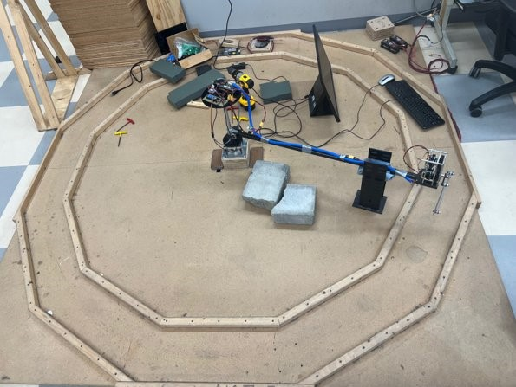
FIGURE 6: THE BOOM TEST SET UP AT CISCOR LAB

Initially, a hopping gait was used to observe the compressibility of the Achilles model and to witness how the hardware performed in tandem with the leg mechanism. Figure 7 shows a demonstration of this equipment. This model mimics a one-dimensional Spring-Loaded Inverted Pendulum (SLIP) Model by bouncing the foot only in the vertical direction.

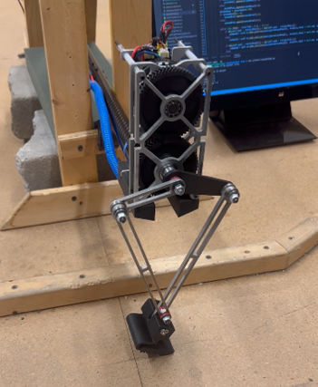
FIGURE 7: BOOM TEST HOPPING GAIT EXPERIMENTAL SET UP

After the hopping gait, a walking gait test on flat ground was completed. Figure 8 shows an instance of this test. A flat surface allowed the observation of all the phases of walking, including stance, compression, and flight. It also gave a preview for how the Achilles model would behave integrated with ET-Quad.

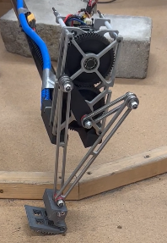
FIGURE 8: BOOM TEST WALKING GAIT ON FLAT GROUND

Following walking on flat ground, the Achilles model was subject to resistive media testing. Figure 9 presents the model crossing regolith simulant from NASA-MSFC. The granular terrain imitated the lunar surface by allowing the model to sink below the surface, thereby repelling the motion of the mechanism.

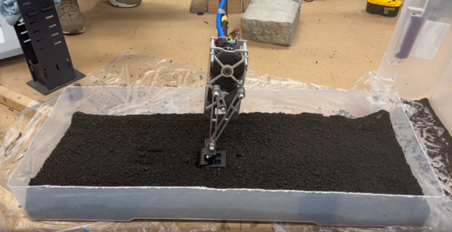
FIGURE 9: BOOM TEST WALKING GAIT ON REGOLITH SIMULANT

- RESULTS AND DISCUSSION
5.1 Regolith Displacement Test Assembly Results
There are two main pieces of data gathered from the RDTA that helped to select the appropriate lattice size. The two key pieces of data are the regolith plume created and the penetration depth each design caused. Figure 10 shows an example image of the regolith plume that one of the designs created.

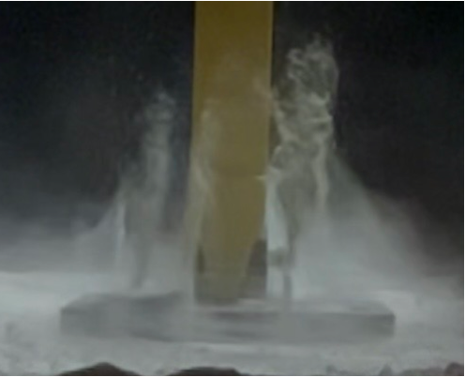
FIGURE 10: A FRAME FROM THE RDTA DROP TEST

Figure 11 shows the results of the plume percentage profile created by each foot in the RDTA.

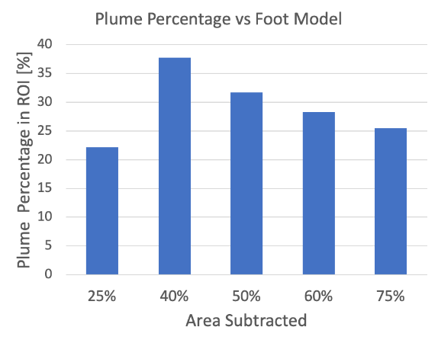
FIGURE 11: PLUME PERCENTAGE VS FOOT SAMPLE TAKEN FROM RDTA RESULTS

While evaluating these results, it became apparent that the lattice design where 25% of the area was taken out did not follow the expected trends. After further investigation, the team determined the design with 25% of the area removed was printed on a different 3D printer and ended up having different density properties. This resulted in that design being treated as an outlier. The other four designs followed the expected trends and the team decided to focus on the lattice designs where 50%, 60%, and 75% of the area had been removed.
Figure 12 shows the average penetration depth that each design caused.

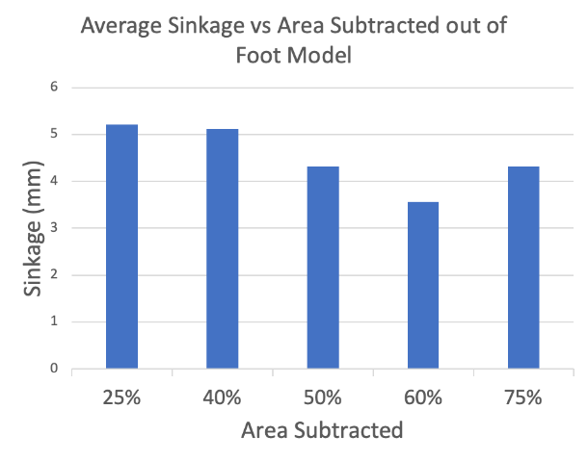
FIGURE 12: PENETRATION DEPTH VS AREA REDUCTION GRAPH FROM RDTA RESULTS

The team expected to see the sinkage each design caused decrease as more area was taken out. Figure 12 shows the negative trend for most designs, but it became evident that the design with 75% of the area removed began to show higher penetration levels. To better understand these results and to determine what was happening during the test, the team decided to compare the mass of each individual foot with the penetration depth they caused.

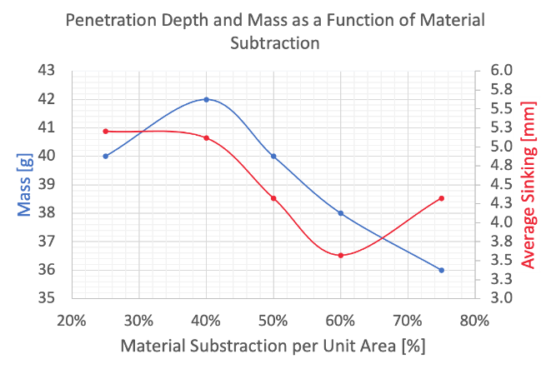
FIGURE 13: MASS AND SINKING VS AREA REDUCTION

Figure 13 confirmed that an increase in area removed will decrease the foot's mass and the penetration depth it causes. This only starts to change between the 60% and 75% area reduction due to a penalty zone that was found. The team discovered that when the mass is decreased too much, the surface area of the foot decreases, which exerts a higher pressure on the surface. This minimized surface area and higher-pressure results in the foot design digging down and sinking deeper into the regolith surface.
The selection of the lattice design became a balancing act between the mass of the foot, the pressure the foot exerted on the surface, the regolith plume that was generated, and the penetration depth that each foot caused. After deliberation, the team decided the lattice design that achieved the best balance and would minimize regolith disturbance was the lattice design where 60% area reduction per unit area had been removed.
To verify the usefulness of the lattice feature, the 60% area redacted design was directly compared to a solid flat plate that had no area removed. The average sinkage for the flat plate was 4.16 mm while the 60% area reduction design presented an average sinkage of 3.57 mm. The plume percentage profile could not be calculated due to the intensity of the regolith plume that the flat plate caused. The flat plate was the only design that caused such an intense plume where simulant escaped the testing apparatus. This validated that a lattice design was an important aspect of the final design. After these trials, the team continued with the lattice design that had 60% of the area removed.

5.2 Traction Test Results
The best traction design will be the one that produces the highest coefficients of friction. The force of friction, $F_{f}$, was experimentally found from the force gauge reading. The normal force, $N$, was calculated by summing the mass of the traction samples with the additional mass. These measurements were taken in grams and were converted to Newtons. The coefficient of static, $μ_{s}$, and dynamic friction, $μ_{k}$, were found from equation (1) by dividing $F_{f}$ by $N$.

$F_{f}=μN$ (1)

After the traction test and calculations were completed, the results were calculated and compiled into Figure 14.
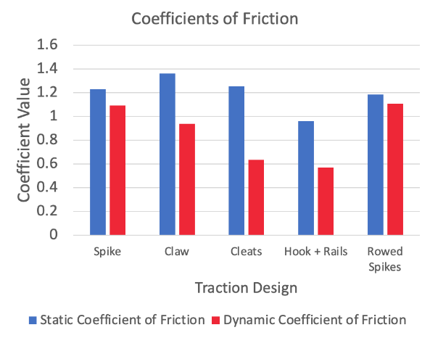
FIGURE 14: COEFFICIENTS OF FRICTION VS TRACTION DESIGN

The Cleat and the Hook and Rails design were immediately eliminated as a traction choice since they presented the smallest dynamic coefficients of friction. The next design determined to be least practical was the Claw design. To generate friction coefficient values that high, the size and radius of the Claws curve had to be increased to such a large amount that it became impractical to integrate that traction design onto a foot. After the analysis, the two final designs to be chosen from where the Spikes and Rowed Spikes design. Figure 15 shows the two final designs. The Spikes design is on the left, and the Rowed Spikes can be seen on the right.

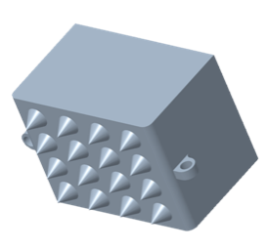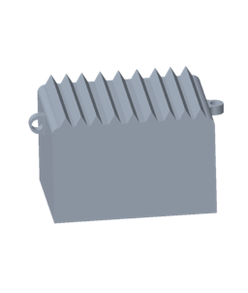
FIGURE 15: THE SPIKED AND ROWED SPIKE TRACTION DESIGNS

These two designs had nearly equivalent coefficients of friction. The Spiked design presented a higher static coefficient of friction while the Rowed Spikes presented a higher dynamic coefficient of friction. To decide what design would be best, the team moved on to manufacturing both designs via 3D-printing and integrating each design with the 60% area lattice. The Spiked design had issues fitting into the small spaces of material left in the lattice design, while the Rowed Spike design easily fit into any configuration of the lattice. The main deciding point between these two was the ability to manufacture and produce each design. Through rapid prototyping, it was determined that the Spiked design could not be easily printed. There were multiple failed prints involving the Spiked design, while the Rowed Spikes always presented clean and accurate prints. This was the main deciding factor for selecting Rowed Spikes to be the best overall traction design for Project Achilles.
5.3 Movement Test Results
The results of the Boom Test verify the combination of the lattice design, traction feature, and compliant structure. The hopping gait confirmed the strength and compressibility of the material. No failure occurred throughout the hopping test or the walking gait phase of the movement tests. Qualitatively, the Achilles model showed minimal plume through the lattice, no slippage because of the traction feature, and satisfactory compressibility during resistive media testing. The CISCOR ET-Quad claw stomped through the regolith, which caused large penetration depths, dispersed simulant omnidirectionally, and clogged the individual tines. Various gait maps were created to customize the experience for both models. The gait itself had to be mapped with a larger retraction such that the models could be lifted out of the regolith simulant. Figure 16 shows the curve that the leg mechanism was following throughout the movement tests.

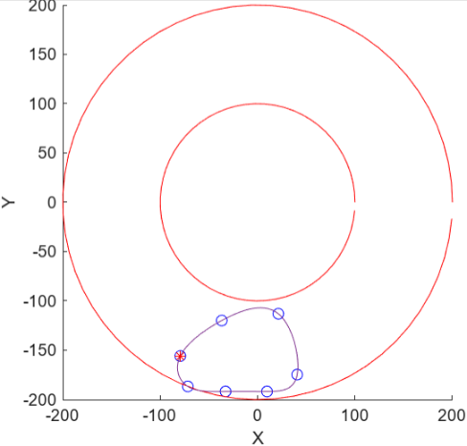
FIGURE 16: LARGER RETRACTION GAIT MAP

Throughout each of the trials for the Boom Test, quantitative data was collected. The main data observed was the Torque on the motors vs. Time, as seen in Figure 17. The minimum in the graph coincides with the compression of the model across the stance phase of walking. As the curve increases to a positive value, the model is in flight, then the maxima shows when the foot lands on the simulant. The signs represent the direction of forces. The noise between each of the phases is from the kickback of the model and oscillatory vibrations sent through the mechanism to the motor sensor. This data was important for verification because it shows a stable steady-state convergence over time with minimal deviations from the peaks. It also showed that the motors were not being overworked.

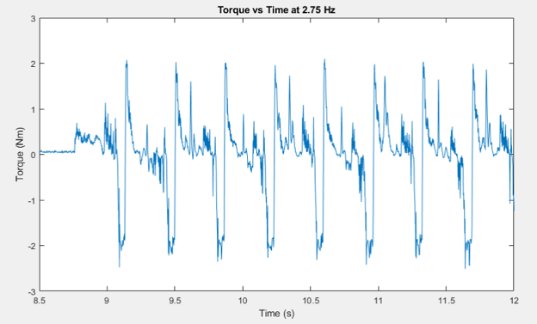
FIGURE 17: TORQUE VS TIME DATA FOR A WALKING GAIT AT 2.75 HZ

The Boom movement tests were critical for determining the success of the Achilles model. During the walking gait test, a lot of regolith simulant was scooped and kicked forward because of the flat top surface. This contrasted with the ET-Quad claw, which sent the simulant in multiple directions. This resulted in optimization to be conducted on the design of the Achilles model. The geometry changed to have a wider base that decreased the pressure on the surface and a curve was created on the front to prevent regolith from being picked up. This was confirmed from additional movement tests by witnessing the locomotion. During compression, simulant reached the top of the arc, but did not fall on the inside of the curve. The regolith that was kicked forward occurred because of the traction design on the bottom. This occurrence could be fixed by retracting the leg mechanism even further within the gait map. The optimization successfully decreased the penetration depth further and minimized the displacement of simulant. Overall, success was found by witnessing no failure, observing the phases of walking, and predicting how the model would be integrated with ET-Quad in the future by moving through deep regolith simulant.

- CONCLUSION
Due to failed lunar expeditions from regolith and its properties, it is important to investigate alternative ways to traverse the lunar surface. Team 518 focused on working with those at the CISCOR lab to determine if a quadrupedal robot with certain foot attachments could successfully traverse deep regolith. The Achilles design focused on 4 key aspects: the lattice, the traction, the compression, and the integration with ET-Quad. Through testing individual components and analyzing the results, decisions were made to allow the Achilles model the best chance at walking through regolith. Through movement tests, such as the Boom Test, the combination of each component and the integration with ET-Quad was verified. The final Achilles model, shown in Figure 18, weighed 47 g, had dimensions of 60 x 76 x 50 mm and has shown that it was our best option to successfully traverse the lunar surface by limiting regolith interference.

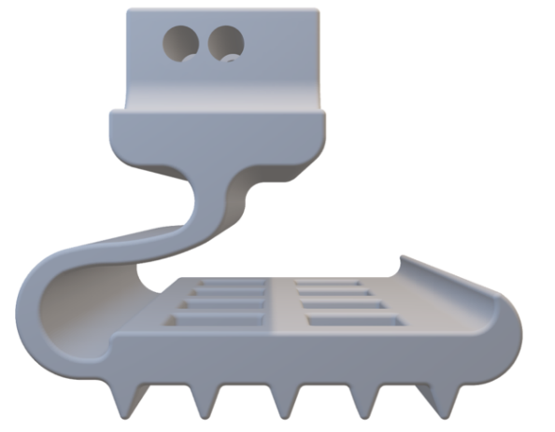
FIGURE 18: FINAL ACHILLES MODEL

ACKNOWLEDGEMENTS
Team 518 would like to thank all the advisors, professors, and peers that helped to make this project successful. A huge thank you to NASA-MSFC for their support, resources, and advice. Team 518 wants to specifically acknowledge Dr. Michael Zanetti and Arthur Werkheiser for their time and help guiding the project. Secondly, Team 518 would like to thank Dr. Jonathan Clark and his team at the CISCOR lab for their time, guidance, and help through all the different testing stages of this project. Next, we would like to thank Dr. Shayne McConomy for his support and advice throughout this project and to make this project possible. Lastly, we would like to thank Pro Hruda for his help with the teams purchasing and manufacturing needs.
REFERENCES
There are no references in this paper.

